1) SOUND ON SOUND, MEDIA HOUSE, TRAFALGAR WAY, BAR HILL, CAMBRIDGESHIRE CB3 8SQ. TEL: 01954 789 888 FAX: 01954 789 895
2) MAKING MUSIC, NEXUS HOUSE, SWANLEY, KENT BR8 8HY.
TEL: 01322 660 070 FAX: 01322 615 636 (Demo section: Andrea Thorn)
3) TOTAL GUITAR, 30 MONMOUTH STREET, BATH BA1 2BW.
TEL: 01225 442 244 FAX: 01225 462 986 (Demo section: Simon Young)
4) SHOWCASE, 38C THE BROADWAY, CROUCH END, LONDON N8 9SU.
TEL: 020 8348 2332 FAX: 020 8340 3750 (Yearbook Music directory)
5) MUSIC WEEK, SPOTLIGHT PUBLICATIONS LTD, LUDGATE HOUSE, 245 BLACKFRIARS RD, LONDON SEl 9UR. TEL: 020 7620 3635 FAX: 020 7401 8036 (Weekly & Directory)
6) THE WHITE BOOK, STUDIO 27 SHEPPERTON STUDIOS, STUDIOS ROAD, SHEPPERTON,
MIDDX: TW17 0QD. TEL: 01932 572 622 FAX: 01932 568 602 (Music Directory)
7) T.M.R. A&R LIST, P.O.ROX 3775, LONDON SE18 30R. TEL/FAX: 020 8316 4690
8) BANDIT, A&R NEWSLETTER, BANDIT PUBLICATIONS, P.O BOX 22, ISLE OF WIGHT
P030 1LZ. TEL: 01983 524 110 CONTACT: MR JOHN WATERMAN
9) VIKING DIRECT, BURSOM INDUSTRIAL PARK, TOLLWELL ROAD, LEICESTER LE4 1BR. TEL: 0800 424 444 FAX: O8OO 622 211 (Discount Office Stationary)
10) DOWNSOFT LTD, DOWNSWAY HOUSE, EPSOM ROAD, ASHTEAD, SURREY KT21 1LD. TEL: 01372 272 422 FAX: 01372 276 122 (Cassette, DAT's, Videos, Reel Tape)
11) STUDIOSPARES LTD, 61-63,ROCHESTER PLACE, CAMDEN TOWN, LONDON NW 9JU.
TEL: 020 7482 1692 FAX: 020 7485 4168 (recording/studio spares etc)
12) SONGWRITING: A COMPLETE GUIDE TO THE CRAFT BY STEPHEN CITRON, HODDER AND STOUGHTON ISBN 0-340 48872-7 THIRD EDITION 1991
13) THE ROCK FILE: MAKING IT IN THE MUSIC BUSINESS, EDITED BY NORTON YORK,
OXFORD PRESS ISBN 0-19-816248-0 FIRST EDITION 1991
14) THE SPIRIT GUIDE TO STUDIO RECORDING, (BY PAUL WHITE), HARMAN INTERNATIONAL INDUSTRIES LTD, CRANBOURNE ROAD, POTTERS BAR, HERTS EN6 3JN. TEL: 01707 660 000 FAX: 01707 660 482
15) UK LETTER RATES LEAFLET (available from Post Offices)
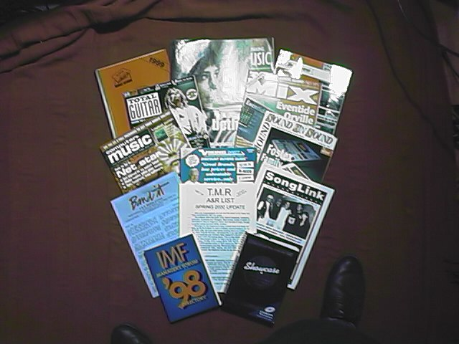
16) A GOOD DICTIONARY 17) ROGET'S THESAURUS (or similar)

