Like any other business it's hard to stress how important good records of your A&R activities are. It'll save you money too in the long run.

If you are approached by a company follow it up fast, if possible the same day.. wait till the following week and you'll probably be too late. People might tell you, if you've written that potential hit song every one's going to be after it, don't kid yourself, they'll take the next one on that list rather than chase it up 99 times out of 100!

Be as systematic as you can, list: -
a) Who you send your demos to every month
b) What songs you send out & to whom
c) Any response i) telephone calls ii) rejection letters (file them, they are very useful for all kinds of future reference) iii) positive responses
d) Cross off all returns from your list as they arrive back
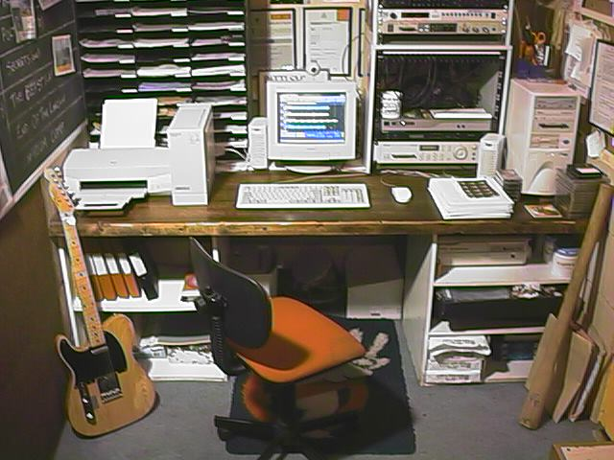
e) Make note of all companies that send your tape back without a letter or rejection slip, don't waste your time on them again
f) Make note of all companies that have i) closed down or ii) moved
g) Try again in six months time with all the companies you've failed at, opinion and taste change as fast as staff!
h) If you can, try to build up a relationship with some of the companies, arrange to drop your next demo off in person. The personal touch works and A&R staff are only human like the rest of us.
i) Don't throw away returned material; re-use it, if it is still in good condition. Likewise re-letter & re-target any un-opened packages. All you need is a few minutes work and a few more stamps for another chance.

STORAGE, by all means keep your records on computer, but keep a) the above records in a file too as a duplicate copy, as computer systems crash don't take my word for it, just risk It! b) A card index system of all key addresses you are using (write on the back of each card, when you posted it out & what songs you sent & follow it up with the result).

YOUR HOME OFFICE

