Now you have a finished master (DAT/open reel/DCC etc) you need to present it in a format for that A&R representative to audition. The following four ways are the most common in the UK:

1) COMPACT CASSETTE, the most popular/cost effective method(p9-1O)
2) CD, either i) one off CD-R ii) short run pressing
3) DAT, now becoming more popular with high quality presentations
4) VIDEO, best avoided unless you have a really professional package

As a rule of thumb a) stick to 3-4 songs per demo b) 3-4 minute tracks only c) put your best track on first, your most complicated on last d) put a short blank leader on the tape eg about 10 seconds e) 3-6 second gaps between the tracks f) if you are using a cassette track, duplicate the entire program again on side two g) don't use any noise reduction system for cassettes

PRESENTING YOUR DEMO
OK your tape needs to stand out on that desk, but it does'nt have to look like the latest package from Michael Jackson! Plain labels and in ex cards in a bright colour stand out,(see address at the back of this book). You must include as much information as possible on the inlay and the cassette labels; (your tape will probably get separated from your biog and package very quickly in a busy office).

The basic minimum on the cassette body should include: - a) Band/Artist name b ) song titles & duration c) contact phone # (& person) d) copyright details. The basic requirements for the inlay card are identical, but if you want a more professional package include the following as well:- a) your contact address b) songwriting credits c ) list of band members & instruments played d ) a short biog e) a small band photograph.

Remember to think of the overall layout & have it printed or typed. A well presented and comprehensive inlay card will be at least as impressive as a commercial cassette in the right hands and worth a lot more than an unmarked tape with a page of possibly illegible handwriting. On the underside of the inlay card (out of view), remember to put the name of the company you are approaching plus the date of submission. This can often help you keep records up to date, when tapes are returned.

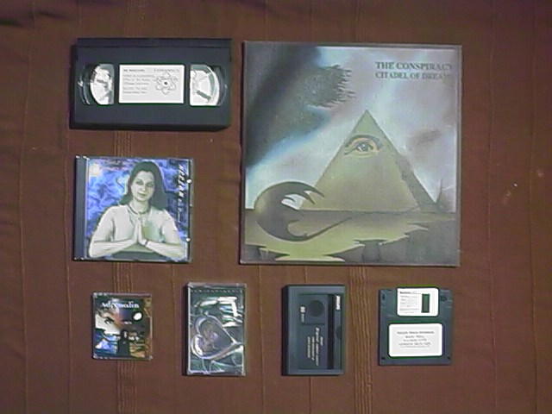
EXAMPLES OF DEMO FORMATS

